

**User Manual**

*Team Perera et.al*



Prepared on: December 6, 2013

## Home Page

Beginning at the **home** page, you can get an introduction about our website:

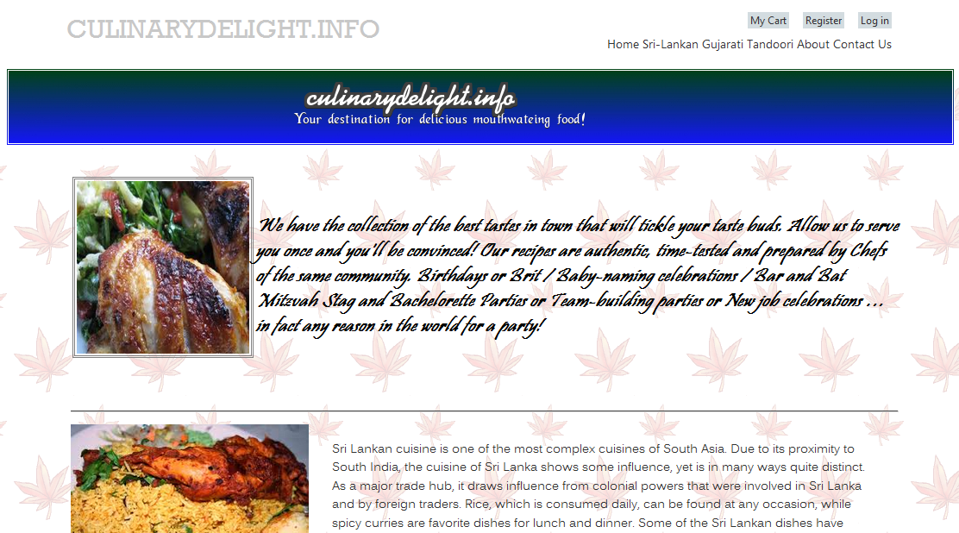

Click the **About** menu on the right to of the page, you can view a detail information about our restaurant:

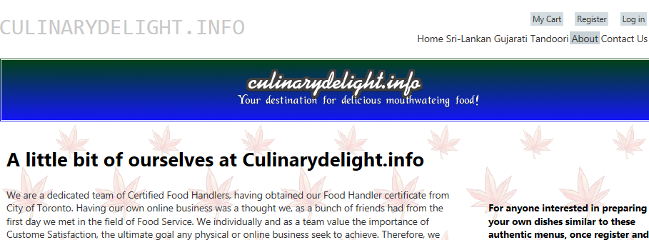

Click the **Contact Us** menu on the right top of page. You can know the contact information and location about the restaurant.

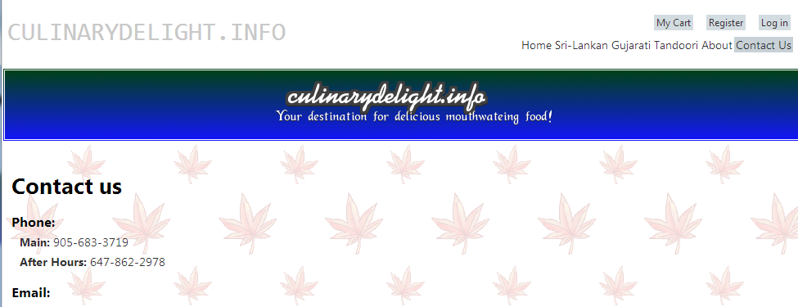

Click the menu of **Sri-Lankkan**, **Gujarati** or **Tandoori**. You can get into each style food page to see what food to available to buy:

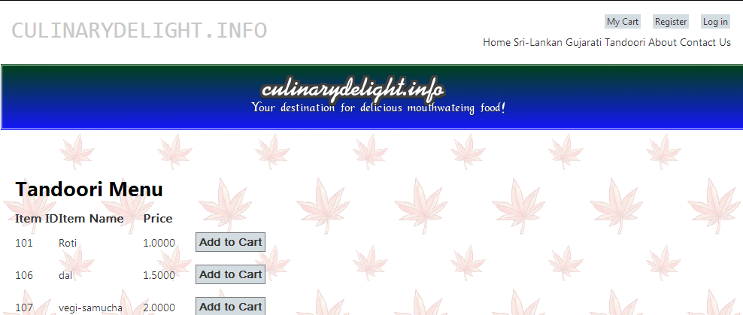

Click the button **Add to Cart** beside the item. You can add the item to your shopping cart.

## In the shopping cart page:

Click **remove** to remove the item from your shopping cart.

Change the **quantity** number, and then click **Update Cart** button to change your item quantity in your cart.

If you want to get more other items, you can click **Back to Product** link or the each style food menu on the top of the page.

Click the **Proceed to Checkout** button. If you are not login yet, system will bring you to the login page. If you have already login, system bring you to the checkout page.

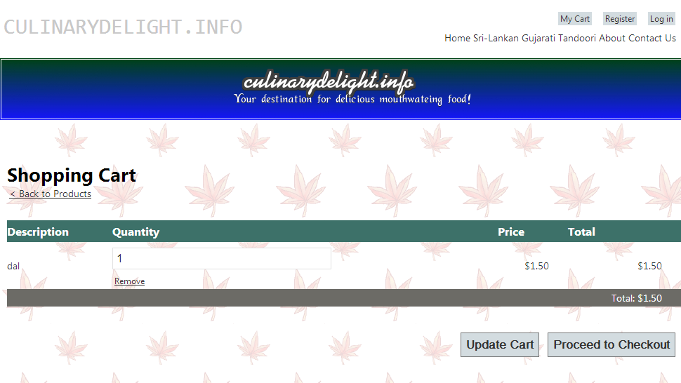

## In checkout page

You will see your order summary and personal information and credit card information. Make sure all are correct. You can click **Place Order** button. This will bring you to PayPay website to pay your order.

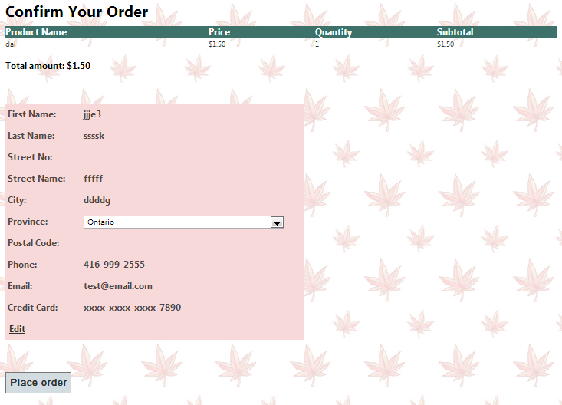

## In the login page

You can get into the login page at any time when you click the **Login** tag on the right top of page.

Enter your user name and password, and then click **Log in** button.

If you don’t have an account yet, you can click **Register** link to get to the registration page.

## In the registration page

Enter user name, password, confirm password, e-mail, security question and security answer. Password must be at least one special character and at least in 7 length.

Click **Sign Up** to create your new account.

System will bring you back the home page as a log in customer.

Click **My Account** link on the top of the page. You can go the customer details page.

## In the customer details page

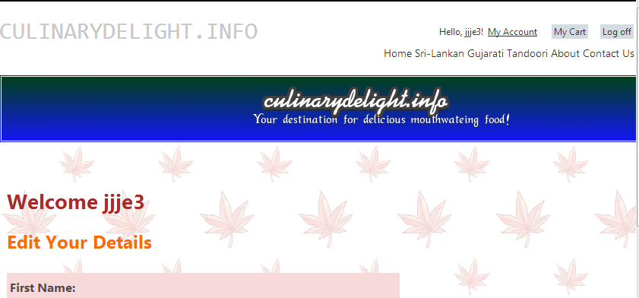

You can click **Edit** link to enter or update your personal information and credit card information

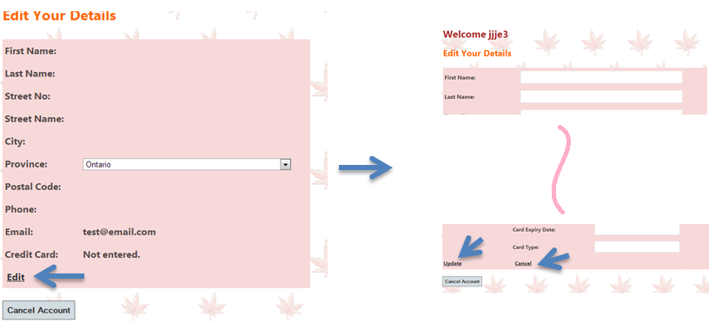

After you finished editing, you can click **Update** to save your information or click **Cancel** to not change anything in your account.

If you click **Cancel Account** button, your account will be removed from the system. You will not be able to login again.

